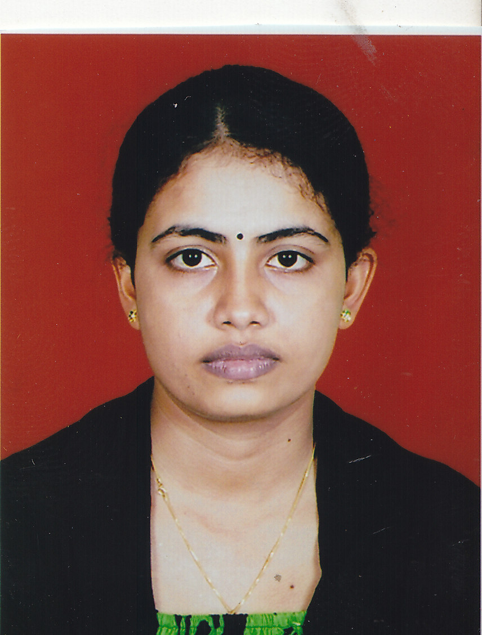 **THIBEKA SRISKANDARAJAH**

***No 128, Vaidya road, Dehiwalla.***

***E-mail: theebasri04@gmail.com***

***Tel: 0094767434243, 0094750434243.***



To enhance my skills by working in an organization that offers challenging environment and professional growth.

* Both Management and IT skills combined with a flexible attitude to work
* Have innovative ideas and ready to take the initiative in working alone or as part of a team
* Get on well with people at all levels and making good working relationships
* Adaptable and fast learner



**TRAINING & WORKING EXPERIENCE:**

* Successfully completed S2O programme conducted by HNB Assurance.
* Successfully completed Internship training at SLT Jaffna.(Implant management)



* Successfully completed Diploma in Microsoft Office.
* Successfully completed Diploma in MS Office & Desktop publishing in UNIT.

|  |  |
| --- | --- |
| **SUBJECTS** | **RESULTS** |
| **Introduction To Computing** | **A** |
| **Applying Statistical Techniques For Business Decision Making** | **A** |
| **Fundamentals Of Marketing Management** | **A-** |
| **Writing Business Documents** | **A-** |
| **Management** | **B+** |
| **Maintaining Financial Records** | **B+** |
| **GPA** | **3.67** |

* Following **HNDM**(**Specialization In Human Resource Management)** in ATI Dehiwalla (Final year)

|  |  |
| --- | --- |
| **SUBJECTS** | **RESULTS** |
| **Introduction to Information Technology** | **A** |
| **Business Economics** | **A** |
| **Making Presentations** | **A** |
| **Fundamentals of Human Resource Management** | **A-** |
| **Business Law** | **A-** |
| **Cost and Management Accounting** | **B** |
| **GPA** | **3.73** |

|  |  |
| --- | --- |
| **SUBJECTS** | **RESULTS** |
| **Managing Human Resource Training & Development** | **A+** |
| **Employee Resourcing** | **A** |
| **Information Technology Application** | **B+** |
| **Writing Specialized Business Documents** | **B+** |
| **Labor Law** | **B** |
| **Understanding Individual Behavior At Work** | **B-** |
| **GPA** | **3.42** |

|  |  |
| --- | --- |
| **SUBJECTS** | **RESULTS** |
| **Ensuring a Safe Workplace** | **A+** |
| **Reward Management** | **A** |
| **Teamwork and Diversity Management** | **A-** |
| **Project Management** | **A-** |
| **Managing Organizational Change** | **B** |
| **Managing Industrial Relations** | **B-** |
| **GPA** | **3.55** |

* Following **CBF**.(REGISTER NO:20055550)



* Successfully completed **General Certificate of Education Ordinary Level**
  + English : A
  + Social studies & history : A
  + Dancing : A
  + Health & Physical education : A
  + Saivism : A
  + Tamil : A
  + Business and accounts : B
  + Mathematics : B
  + Science : B
  + English Literature : S
* Successfully completed **General Certificate of Education Advance Level** in Science Stream.
  + Physics : S
  + Chemistry : S
  + Biology : S
  + English : S



**LANGUAGE SKILL:**

**LANGUAGE UNDERSTAND SPEAK READ WRITE**

**ENGLISH** Very Good Very Good Very Good Very Good

**TAMIL** Very Good Very Good Very Good Very Good

**SINHALA**  Basic Basic Basic Basic



* Working for results with dedication and determination.
* Positive, confident attitude and ability to work under pressure
* Have the perseverance to work till I get the desired result.
* Good communication skills, Fast learning ability and Good logical skills.



* Participated English competition every year and take places.
* Participated Tamil competition every year and take places.
* Gold Medalist of Oratory prepared competition.
* Editor of the Science Union.
* Vice President of the English Union.
* Captain of Athletic Team Rathy House.
* **Post Held in School:** Senior Prefect in Our School



**Surname :** SRISKANDARAJAH

**First name** **:** THIBEKA

**Date of birth** **:** 21st September 1991

**Gender :** Female

**NIC :** 917652821V

**Civil Status** **:** Single

**Nationality** **:** Sri Lankan

**School Attended :** J/Jaffna Hindu Ladies’ College.  
**Permanent Address :** 282, Jaffna road, Manipay.



Mrs. S.Subakaran

Senior lecturer,

Advanced Technological Institute,   
Dehiwalla.

Tel: +94718569962

Mr.S.Janarthanan,

Assistant Manager,

SLT Jaffna,

Tel: +94711433637 / 0212222015

E-mail: sjana@slt.com.lk

I do hereby declare that foregoing particulars are true and accurate to the best of my knowledge.

.

**Thibeka Sriskandarajah**